Question Number | Scheme | Marks
1.  (a)  (b)  2. (a)  (b)  (c) | substitute x=100 to obtain  601⁴ = 1 + 2400 + 2160000 + 864000000 + 129600000000  = 130,466,162,401  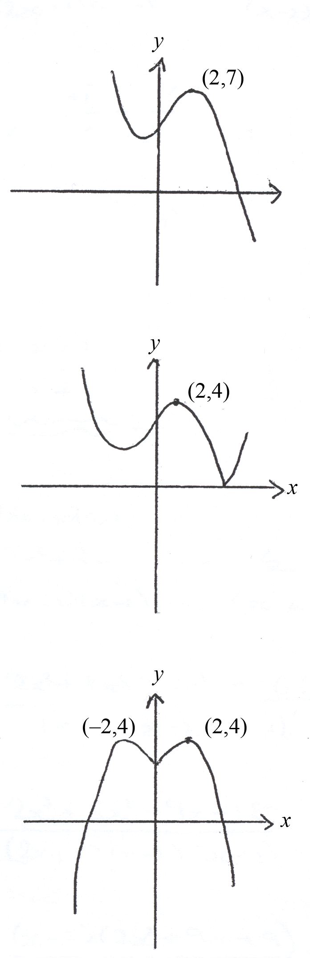 | M1 A1  A1  (3)  M1o.e.  A1 (2)  B1 Shape  B1 Point  (2)  B1 Shape  B1 Point  (2)  B1 Shape >0  B1 Shape x<0  B1 Point  (-2,4)  (3)
3. | Alternative 1  ,  Alternative 2:  $$\frac{2x^{2}+3x}{(2x+3)(x−2)}−\frac{6}{x^{2}−x−2}$$  $$=\frac{x(2x+3)}{(2x+3)(x−2)}−\frac{6}{x^{2}−x−2}$$  $=\frac{x(x^{2}−x−2)−6(x−2)}{(x−2)(x^{2}−x−2)}$,$=\frac{x^{3}−x^{2}−2x−6x+\text{12}}{(x−2)(x^{2}−x−2)}$  $$=\frac{x^{3}−x^{2}−8x+\text{12}}{(x−2)(x^{2}−x−2)}$$  $$=\frac{(x−2)(x^{2}+x−6)}{(x−2)(x^{2}−x−2)}$$  $=\frac{(x+3)(x−2)}{(x−2)(x+1)}$, $=\frac{x+3}{x+1}$ | B1, B1  M1 A1ft  M1 A1  A1 (7)  B1  M1 A1ft  A1  M1  A1, A1  B1  M1A1ft  A1  M1  A1,A1

Question Number | Scheme | Marks
4.  5. (a) | At x=3, gradient of normal =$\frac{−1}{\frac{1}{3}}=−3$  AG  Alternative 1:  AG  Alternative 2:  $$x^{2}=\frac{2}{x}+\frac{1}{2}$$  $$2x^{3}=4+x$$  $$2x^{2}−x−4=0$$ | M1 A1  M1  M1  A1 (5)  M1  M1  A1 (3)  M1  M1  A1  M1  M1  A1
(b)  (c)  6. (a)  (b) | 1.41, 1.39, 1.39  (1.40765, 1.38593, 1.393941)  change in sign means root between  1.3915 & 1.3925  $$−2x+4=\frac{3}{2x}$$  Alternative solution:  Area $=\int{−2x+4−\frac{3}{2x}}\text{dx}$  $$={\left[−x^{2}+4x−\frac{3}{2}\text{ln}x\right]}_{0\text{.}5}^{1\text{.}5}$$  $=\frac{−9}{4}+\frac{1}{4}+6−2−\frac{3}{2}\text{ln}3$ o.e.  $$=2−\frac{3}{2}\text{ln}3$$ | B1,B1,B1  (3)  M1  A1  B1 (3)  M1  A1  M1  A1 (4)  M1  A1  M1 A1  A1ft  A1 (6)  M1  M1A1A1  A1ft  A1
7. (a)  (b)  (c)  (d)  8. (a)  (b)  (c)  (d) | trapezium rule overestimates will be enough  $$\text{gf}(x)=e^{2(2x+\text{ln}2)}$$  $=e^{4x}e^{2\text{ln}2}$  $=e^{4x}e^{\text{ln}4}$  $=4e^{4x}$ AG  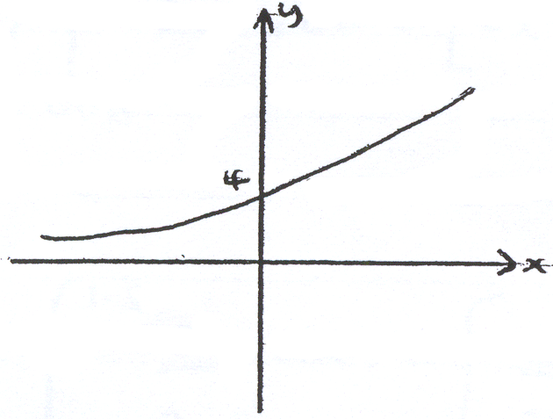 | B1, B1, B1  (3)  B1,M1,A1ft  A1 (4)  B1 ft (1)  B1B1 (2)  M1  M1  M1  A1 (4)  B1 shape & (0,4)  (1)  B1 (1)  M1  M1 attempt to solve  A1  A1 (4)
  0 | 1 | 2 | 3 | 4 | 5
  0 | 0.062 | 0.271 | 0.716 | 1.612 | 3.482
9. (a) (i)  (ii)  (b)  (c) | AG  $$\frac{1}{2}(\text{cos}2x−\text{sin}2x)=\frac{1}{2}(2{\text{cos}}^{2}x−1−2\text{sin}x\text{cos}x)$$  $={\text{cos}}^{2}x−\frac{1}{2}−\text{sin}x\text{cos}x$ AG  $$\text{cos}θ\left(\frac{\text{cos}2θ}{\text{cos}θ+\text{sin}θ}\right)=\frac{1}{2}$$  $$\text{cos}θ(\text{cos}θ−\text{sin}θ)=\frac{1}{2}$$  $${\text{cos}}^{2}θ−\text{cos}θ\text{sin}θ=\frac{1}{2}$$  $$\frac{1}{2}\left(\text{cos}2θ+1\right)−\frac{1}{2}\text{sin}2θ=\frac{1}{2}$$  $$\frac{1}{2}(\text{cos}2θ−\text{sin}2θ)=0$$  $\text{sin}2θ=\text{cos}2θ$ AG | M1  A1 (2)  M1, M1  A1 (3)  M1  M1  A1 (3)  M1  A1 for 1  M1(4 solns)  A1 (4)

