June 2005

6673 Pure P3

Mark Scheme

Question Number | Scheme | Marks
1. (a)  (b)  (c)  2. (a)  (b) | Finding f (2), and obtaining 16 – 32 + 10 + 6 = 0  Or uses division and obtains ,  obtaining and concluding remainder = 0  Finding f ( ), and obtaining  Or uses division and obtains ,  obtaining and concluding remainder =  x = 2 ( also allow or )  Writes down binomial expansion up to and including term in , allow notation (condone errors in powers of a)  States na =15  Puts (condone errors in powers of a )  3 = (n – 2 )a  Solves simultaneous equations in n and a to obtain a = 6, and n = 2.5  [ n.b. Just writes a = 6, and n = 2.5 following no working or following errors allow the last M1 A1 A1]  Coefficient of  (or equals coefficient of ) | M1, A1  M1  A1  M1, A1  B1  (5)  M1  B1  dM1  M1 A1 A1  (6)  B1  (1)  [7]

Question Number | Scheme | Marks
3. (a)  (b)  4 (a)  (b)  (c) | Attempt at integration by parts, i.e., with k = 2 or ½  =  Integrates sin 2x correctly, to obtain (penalise lack of constant of integration first time only)  Hence method : Uses cos 2x = to connect integrals  Obtains =  Otherwise method  B1 for  =  r = 3 ( both circles)  Centres are at ( 2, 0) and ( 5, 0)  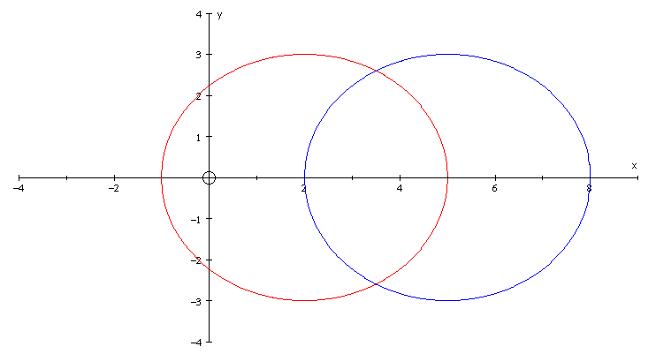  1st circle correct quadrants  centre on x axis  2nd circle correct quadrants  centre on x axis  circles same size and passing  through centres of other  circle  Finds circles meet at x = 3.5, by mid point of centres or by solving algebraically  Establishes y =, and thus distance is .  Or uses trig or Pythagoras with lengths 3, angles 60 degrees, or 120 degrees.  Complete and accurate method to find required distance  Establishes distance is . | M1  A1  M1, A1  (4)  B1  M1 A1  (3)  B1, M1  A1  (3)  B1  B1, B1  (3)  B1  B1  B1  (3)  M1  M1, A1  (3)  M1  M1  A1  (3)
Question Number  5. (a)  (b)  (c)  6, (a)  (b)  (c) | Scheme  Substitutes t = 4 to give V, = 1975.31 or 1975.30 or 1975 or 1980 (3 s.f)  ;= -800.92 or –800.9 or –801 M1 needs ln 1.5 term  rate of decrease in value on 1st January 2005  or ,  Substitutes to give the point P, (Accept (-4, 3, 1)  Finds the length of OA, or OB or OP or AB as or or or resp.  Uses area formula- either  Area = or =  or = or =  = or  or or  = 27.9 | Marks  M1 , A1  (2)  M1 A1; A1  (3)  B1  (1)  M1 , A1  A1  (3)  M1 A1  M1  A1  M1, A1  (6)  M1  M1  M1  A1  (4)
Question Number  7 (a)  (b)  (c)  _______ | Scheme  ___________________________________________________________________  As  Using chain rule  = *  (allow mark at this stage, does not need r =)  Use r =5 at t =0 to give c= or 2604 or 2600  Use r = 6 at t = 2 to give B = or 2586 or 2588 or 2590  Put t = 4 to obtain (approx 78000 )  Then take sixth root to obtain r = 6.53 (cm)  __________________________________________________________________________ | Marks  __________  M1  M1 A1  A1  (4)  B1  M1 A1  (3)  M1  M1  M1 A1  A1  (5)  __________

Question Number  _______  8. (a)  (b)  (c) | Scheme  ___________________________________________________________________  and  and at t = ½, gradient is –9 M1 requires their dy/dt / their dx/dt  and substitution of t.  At the point of contact x = and y =2  Equation is y – 2 = -9 ( x - )  Either obtain t in terms of x and y i,e, (or both)  Then substitute into other expression y = f(x) or x = g(y) and rearrange  (or put and rearrange)  To obtain *  Or Substitute into  =  = y *  Area =  = = putting into a form to integrate  =  =  = or any correct equivalent. | Marks  __________  B1, B1  M1 A1cao  B1  M1 A1  (7)  M1  M1  A1  (3)  M1  A1  M1  (3)  B1  M1  M1 A1  M1  A1  (6)
Question Number  _______  8.  (c) | Scheme  ___________________________________________________________________  Or Area =  = putting into a form to integrate  =  = =  Or Area =  = putting into a form to integrate  =  = Using limits 0 and ½ and subtracting (either way round)  = or any correct equivalent.  Or Area = then use parts  = | Marks  __________  B1  M1  M1A1  dM1 A1  (6)  B1  M1  M1 A1ft  dM1  A1  (6)  B1  M1  M1A1  DM1  A1

